2019 Club Championships
The 2019 Club Championships were played as usual during the latter part of October. The tennis throughout was played in great spirit and to a high standard. It is gratifying that the once struggling Ladies Open Singles event is still gaining momentum. A big thank-you goes out to all the ladies who participated and made this possible.
For the first time since 2004, we had enough men’s singles entries to conduct the Men’s Singles Plate that is played by the first and second round losers in the men’s open singles.
Again, this year the Special (Handicap) events were conducted in a round-robin format, which has proved very popular with participants. It was very encouraging to see lots of entries as this gives those who are not necessarily the best players a chance to be on the courts over the two weekends.
The 2019 winners are:
- Men's Open Singles Andy Bennett
- Ladies Open Singles Janice Gibson
- Men's Open Doubles Nima Kermani & Jackson McGenniss
- Ladies Open Doubles Janice Gibson & Ruth Jarvis
- Mixed Open Doubles Regan Bull & Andy Bennett
- Men’s Singles Plate Dave Williams
- Men’s Handicap Singles Edy Sirca
- Ladies Handicap Doubles Liz Finniecome & Katrina Rendell
- Mixed Handicap Doubles Sharon Morse & Brendan Morse
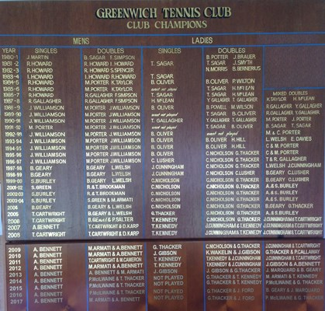
Thank you in particular to the ever-energetic Tim Thacker, who ran the Club Championships and contributed hugely to their success.
Club Champions
The Club Champions Honours Board from 1980 when Club Championship Tournaments commenced is shown below.

Mens Singles "Plate Award"
The Men's Singles Plate award was held every year from 1991 - 2004 with those knocked out of the first or second round of the Men's Singles playing off for the trophy. In subsequent years a Handicap competition has been held including men's and ladies singles and doubles and a mixed competition.
